THE GREAT CHEESE HUNT

A NEW MICROMOUSE EVENT

TECHNICAL BULLETIN #2

PUBLICATION RIGHTS RESERVED

ADDRESS QUESTIONS TO:

DR. ANDREW R. SASS

IEEE, L.I. SECTION

arshacker@aol.com

INTRODUCTION

This bulletin is an update to SCOPE traces shown in TECH BULLETIN #1 CHEESE HUNT.

UPDATE

Fig. 2 in the Technical Details section and the scope pictures, Scope 1, Scope 2, and Scope 3 in Appendix 1 were taken for very low values of the resistor (1K-2K ohms) in series with the IR LED. The low values were used during early experimentation.

During this early experimentation, the range of the beacon was excessively high for the Maze application. To reduce the range, the resistor value was increased to 147K ohms, as shown in Fig. 1 of Tech Bulletin #1.

147K Ohms is needed in order to limit the range of the IR signal to less than about 18 cm. Limiting the range is necessary for proper operation of the Competition.

Scope pictures for 147K ohms were NOT shown in Tech Bulletin #1 and will be shown here.

This resistance value increases the time constant of the circuit and results in the following scope pictures for the 147K ohm case. The blue trace is the IR Beacon signal and the red trace is the detected Sensor signal.

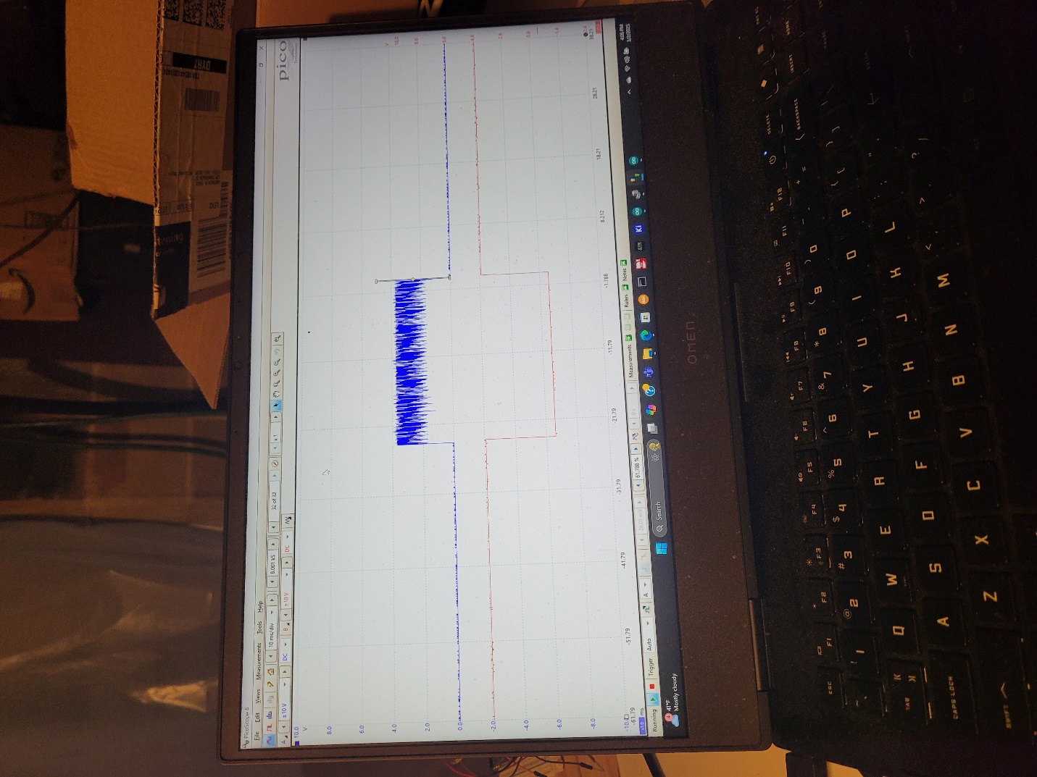

Compare these to the blue and red traces in the scope pictures in Tech Bulletin # 1. Note that while there is a change in the DC level of the 38kHz component of the IR LED Beacon signal, the Sensor signal is the same as shown in TECH BULLETIN #1. This is because the 38 kHz bandpass filter in the Sensor only passes the 38 kHz signal and not the DC level.

Changing the value of the series resistor to the value mentioned above does not change the basic Sensor operation while successfully limiting Beacon range.

THEREFORE, NO CHANGES TO THE HARDWARE OR SOFTWARE DISCUSSED IN TECH BULLETIN #1 ARE NEEDED.

THE PURPOSE OF THIS UPDATE WAS INFORMATIONAL ONLY, FOR THOSE ENGINEERS SPECIFICALLY INTERESTED IN THE SCOPE TRACES.

Let me know if you have any questions.

Andrew

Dr. Andrew R. Sass

Vice Chair, IEEE RAS OF L.I.

arshacker@aol,com